Assignment 1: Launch an EC2 instance using Terraform and Install Jenkins, Java and Python in Instance

Step 1: Install Terraform using below command
wget -O- https://apt.releases.hashicorp.com/gpg | sudo gpg --dearmor -o /usr/share/keyrings/hashicorp-archive-keyring.gpg
echo "deb [signed-by=/usr/share/keyrings/hashicorp-archive-keyring.gpg] https://apt.releases.hashicorp.com $(lsb_release -cs) main" | sudo tee /etc/apt/sources.list.d/hashicorp.list
sudo apt update && sudo apt install terraform
O/P

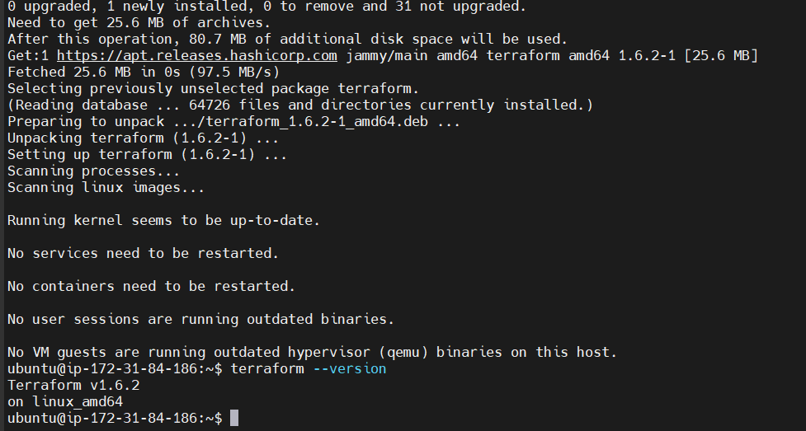

Step 2: Use AWS Api Access Key from practice lab
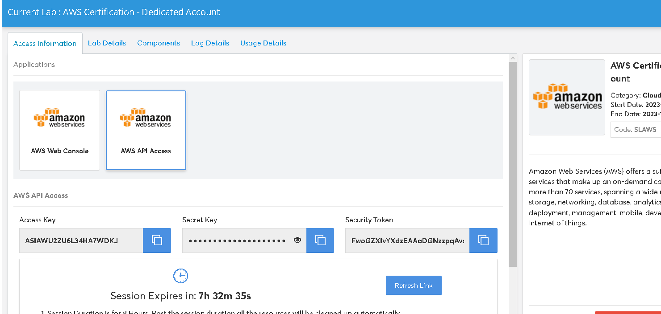
Step 3: Now create Cred.tf and Main.tf file
Cred.tf file is contain all security credentials like access key, token key and security token
$ Vi cred.tf
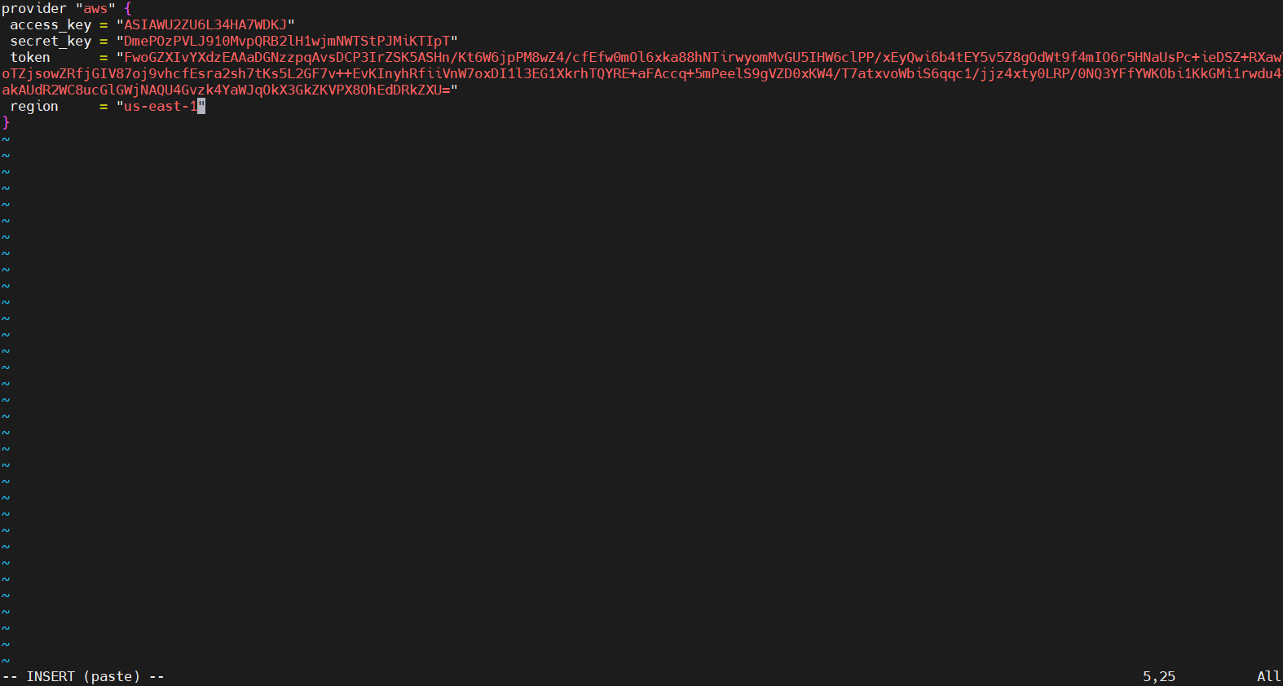

Now create main.tf file It contain what resource we need to setup like s3 bucket, EC2 Configuration
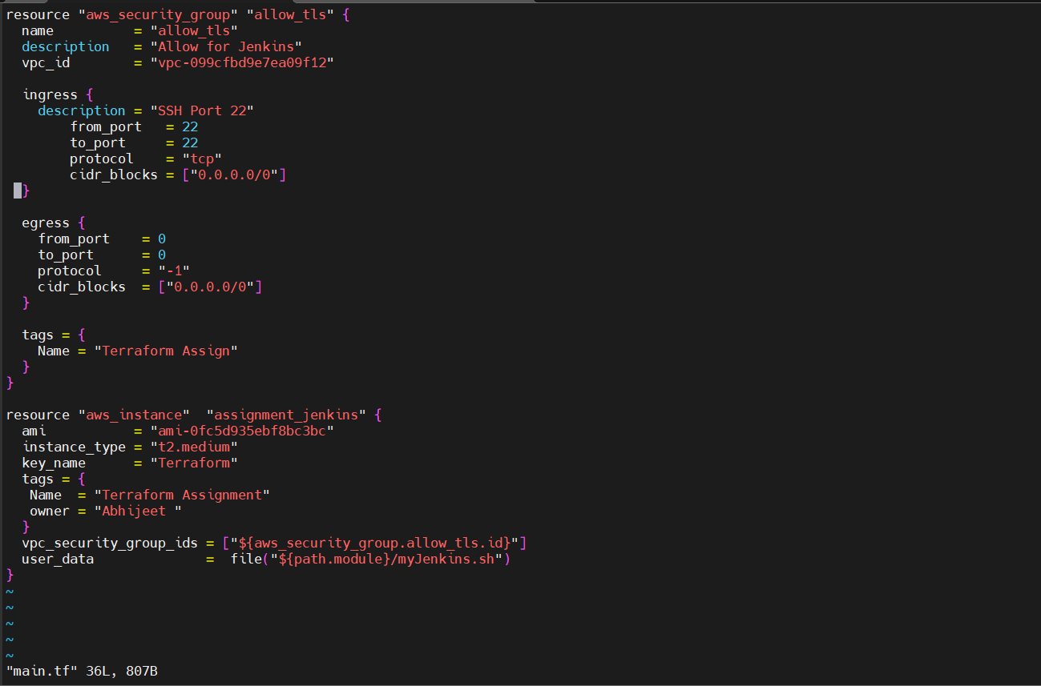

Step 4: Create Script file myJenkins.sh and Install Java, Jenkins and Python
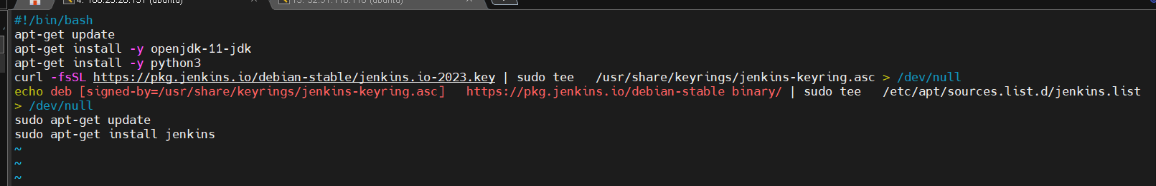

Step 4: No Initialize Terraform using below command
$ terraform init
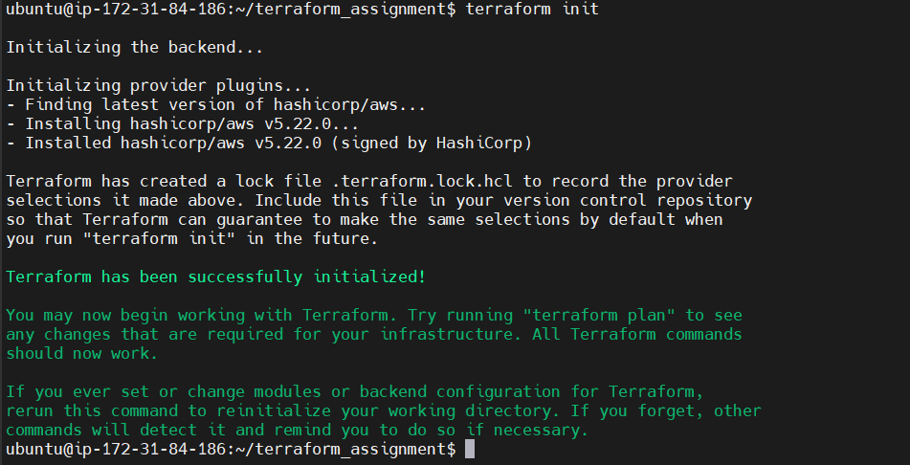

Step 5: Validate Terraform using below command
$ terraform validate
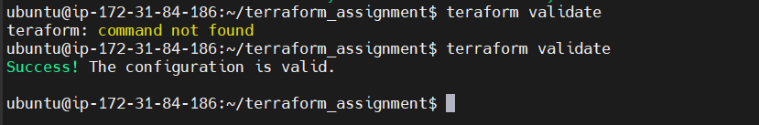

Step 6: Now enter Terraform apply command to apply configuration
$ terraform apply
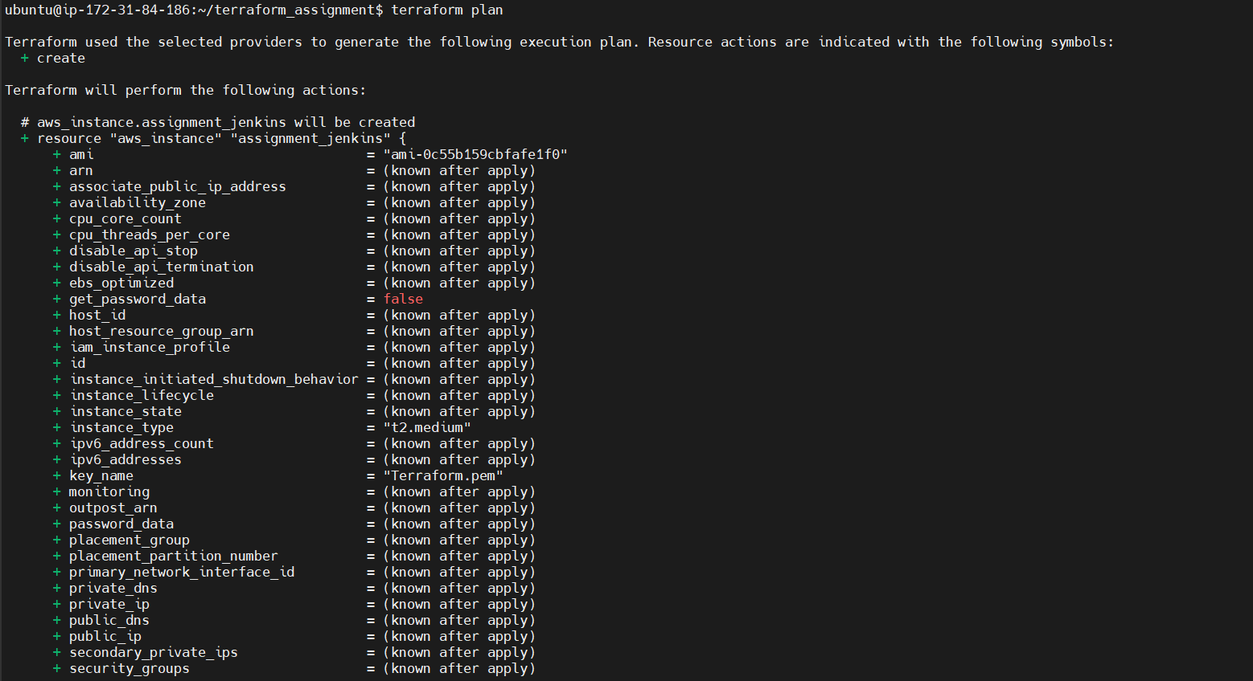

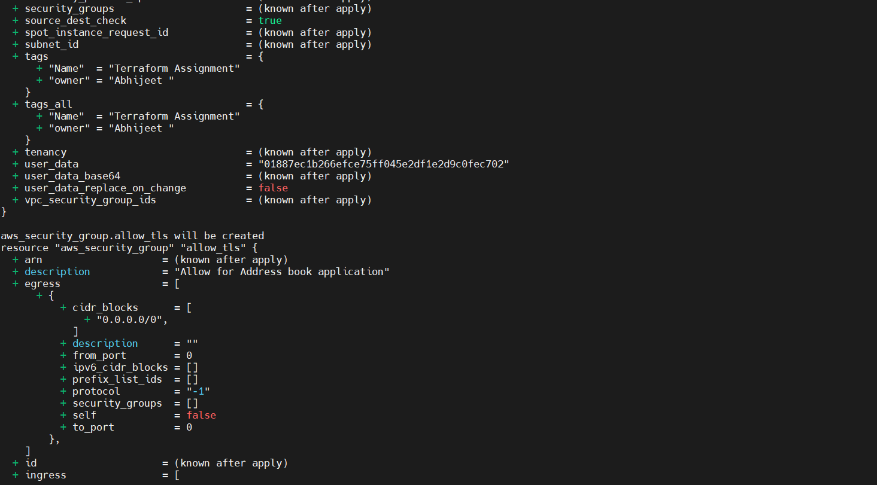
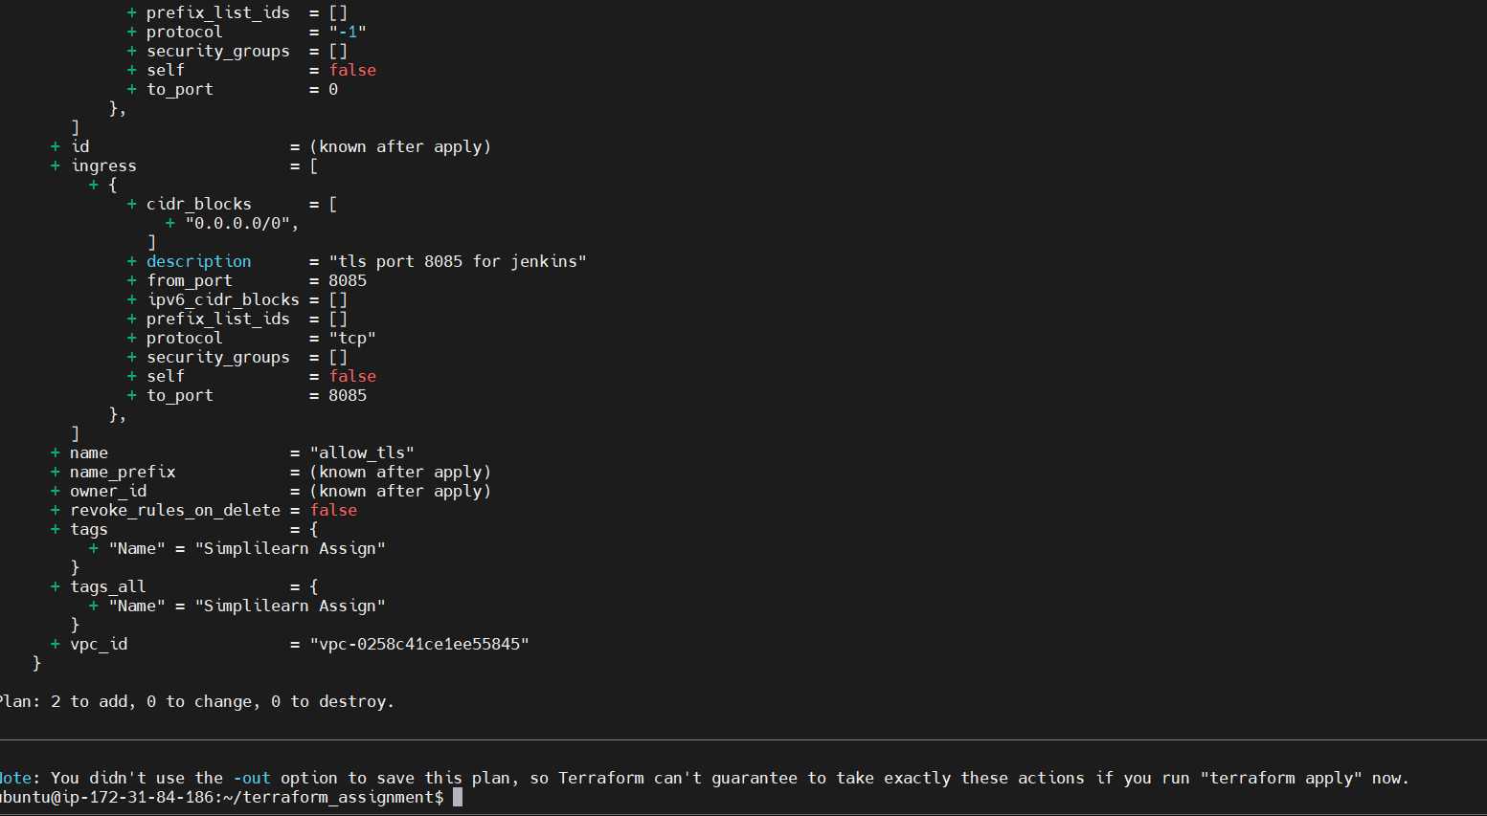

Step 7: Step 6: Now enter Terraform apply

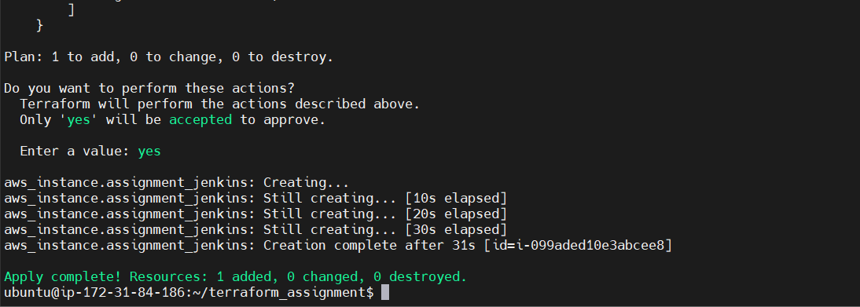

Output :
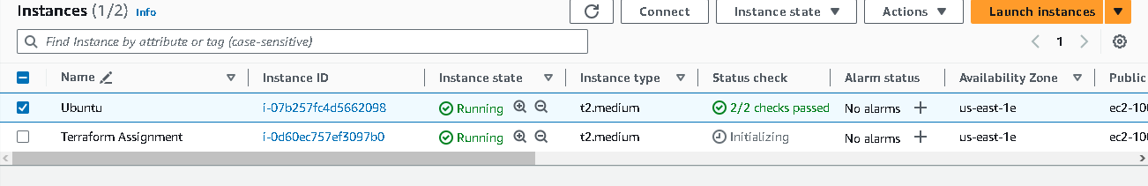

Successfully configured Java, Python and Jenkins

